Bible life messages
How Can I Live to Really Please God?
I Thessalonians 4:1-12

₁ “Benedict’s Scrapbook” tells of a publication which offered a prize for the best answer to the question, “Why is a newspaper like a good woman.” The winning answer was, “It’s like a good woman because every man should have one of his own and not look at his neighbor’s!”
When your life is lived for the purpose of pleasing God and presenting a positive Christian witness to those around you, you will benefit by having a meaningful and joyful life! ₂
So, how can I live my life to really please God? First Thessalonians, chapter 4, verses 1 through 12, tell us a couple of ways. ₃
Finally, brothers, we instructed you how to live in order to please God, as in fact you are living. Now we ask you and urge you in the Lord Jesus to do this more and more. For you know what instructions we gave you by the authority of the Lord Jesus. ₄
It is God’s will that you should be sanctified: that you should avoid sexual immorality; that each of you should learn to control his own body in a way that is holy and honorable, not in passionate lust like the heathen, who do not know God; and that in this matter no one should wrong his brother or take advantage of him. The Lord will punish men for all such sins, as we have already told you and warned you. For God did not call us to be impure, but to live a holy life. Therefore, he who rejects this instruction does not reject man but God, who gives you his Holy Spirit. ₅
Now about brotherly love we do not need to write to you, for you yourselves have been taught by God to love each other. And in fact, you do love all the brothers throughout Macedonia. Yet we urge you, brothers, to do so more and more. Make it your ambition to lead a quiet life, to mind your own business and to work with your hands, just as we told you, so that your daily life may win the respect of outsiders and so that you will not be dependent on anybody. ₆
The first way is to . . .
I. Keep Pure Relationships with
One Another – v1-8
Keep pure relationships with one another. ₇
What does purity mean? ₈
Verse 3 says that purity means that you should be sanctified. Sanctify means to be dedicated, consecrated, to be separated apart from others by your spirituality. In the original language this word is related to the words “saint” and “holy”. ₉
It means you should avoid sexual immortality. This word means “fornication”. In fact, we get our English word “fornication” and “pornography” from this word. ₁₀
Fornication and adultery are related.
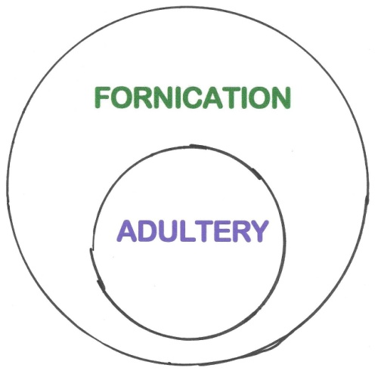
Fornication is a any person having sexual activity with anyone who is not his (or her) spouse. Adultery is a married person having sexual activity with anyone who is not his (or her) spouse. ₁₁
Verse 4 deepens the idea of purity as learning to control your own body with honoring God’s will rather than the way of the world. ₁₂
Why is this important? ₁₃
In verse 1 we have Finally, brothers, we instructed you how (it is necessary) to live in order to please God . . . The phrase “it is necessary” is not in our English text but is in the original language. It is a bit awkward to stick it in and the translators probably thought that phrase was redundant. It may be but including that phrase does add an extra punch to how important it is in how to please the Lord. ₁₄
In verse 2, it is a command. For you know what instructions we gave you by the authority of the Lord Jesus. ₁₅
Verse 3 and 4 tell us it is God’s will! ₁₆ After all, it is the 7th Commandment, You shall not commit adultery. ₁₇
Job made the commitment; I made a covenant with my eyes not to look lustfully at a girl. For what is man’s lot from God above, his heritage from the Almighty on high? ₁₈
The Lord’s take on this is found in the Sermon on the Mount, You have heard that it was said, ‘Do not commit adultery.’ But I tell you that anyone who looks at a woman lustfully has already committed adultery with her in his heart. ₁₉
Another reason this is important is found in verse 6; so that your relationship with your Christian brother will not be hampered! ₂₀
The final reason this is important is in verse 7; your call to be a Christian (the cross) was for the purpose of living this pure life. For God did not call us to be impure, but to live a holy life.
So, the first way to live your life to really please God is to keep pure relationships with one another. ₂₁
The second way is to . . .

II. Keep Love Relationships with
One Another – v9-12
Keep loving relationships with one another. ₂₂ What does love here mean? ₂₃
Notice verse 10, And in fact, you do love all the brothers throughout Macedonia. Yet we urge you, brothers, to do so more and more. This means, love more than you’re loving now!
You can’t love too many people. Suzanne Wesley was the mother of John and Charles Wesley. They founded the Methodist Movement in England and wrote many of the Christian hymns we sang as we were growing up. When asked which of her nineteen children she loved the most her answer was, “Whichever one needs it the most at the time”.
You have to work at loving. In your marriage it takes effort sometimes, maybe a lot of times! You certainly have to work at loving unfriendly people, right? ₂₄
Then there’s this slant to love found in verses 11 and 12, Make it your ambition to lead a quiet life, to mind your own business and to work with your hands, just as we told you, so that your daily life may win the respect of outsiders and so that you will not be dependent on anybody. Love must be expressed in practical living. In Thessalonica, the church members were quitting their jobs and sitting around waiting for the Lord’s Second Coming. They thought it would happen any day. They were really expectant! ₂₅
How are we to wait for the Lord’s return? ₂₆
What do you do with your life? Live it in consideration, respect and love for others. ₂₇
What do you do with your thoughts? Quietly mind your own business. ₂₈
What do you do with your time? Get a job, “work with your hands”, so you will be respected and not be dependent on other people. ₂₉
Why is this important? ₃₀ Verse 9, Now about brotherly love we do not need to write to you, for you yourselves have been taught by God to love each other. You were taught this by God! ₃₁
Through the Lord Himself, This is my command: Love each other. ₃₂
Through the Apostle John, And he has given us this command: Whoever loves God must also love his brother. ₃₃
Through the Apostle Paul, . . . live a life of love, just as Christ loved us and gave himself up for us as a fragrant offering and sacrifice to God. ₃₄
You were born again into a family relationship. How can I live to really please God? Keep pure and loving relationships with one another!

http://biblelifemessages.org/

“Our Daily Bread”, August 16.
v1-2.
v3-8.
v9-12.
ἁγιασμός.
πορνεία.
δεῖ.
It is God’s will that you should be sanctified: that you should avoid sexual immorality; that each of you should learn to control his own body in a way that is holy and honorable . . .
Exodus 20:14.
Job 31:1-2.
Matthew 5:27-28.
v6-7 - . . . and that in this matter no one should wrong his brother or take advantage of him. The Lord will punish men for all such sins, as we have already told you and warned you. For God did not call us to be impure, but to live a holy life.
v10 & 12 - . . . love all the brothers . . . that your daily life may win the respect of outsiders and so that you will not be dependent on anybody.
v11.
John 15:17.
I John 4:21.
Ephesians 5:2.

