Bible life messages
You Can Be a Slave & Be Free at the Same Time
Romans 6:15-23

₁ The story is told of a wealthy Christian man who lived in the South prior to the American Civil War. He paid a rather high price for a particular slave. Since he hated slavery, his reason for buying the slave was to set him free. The Christian man said to the slave, “It is true, I bought you, but I did it to free you from the terrible bondage you have known.” He then handed the freed slave the necessary documents which would guarantee his freedom.
The slave looked down at the papers he had in his hands in awe and gasped, “Am I truly free? Am I my own? May I go where I wish?” “Yes”, said the Christian, “that’s why I bought you so you could be free from those chains forever.”
Overwhelmed, the slave fell at the Christian’s feet and said with devotion, “My greatest joy and freedom will be to stay with you and serve you gladly for the rest of my life.”
You can be a slave to the authority God has over you and still be free at the same time. God intended, all along, to have the same relationship with you this former slave had with his benevolent Christian master. Notice what this passage of scripture is telling you.
I. You Are a Slave Whether You Admit It or Not – v15-16 ₂
First, you are a slave whether you admit it or not! From Romans, Chapter 6, verses 15 and 16, ₃ What then? Shall we sin because we are not under law but under grace? By no means! Don’t you know that when you offer yourselves to someone to obey him as slaves, you are slaves to the one whom you obey — whether you are slaves to sin, which leads to death, or to obedience, which leads to righteousness?
You may say, ₄ “Wait a minute. I live in a free country. I can do anything I please!” Can you? ₅ Even in a free society, your freedom ends where they infringe on the freedom of your neighbor. ₆ The Bible says that pleasing yourself is actually serving sin. So, ₇ pleasing you is not real freedom! ₈
As a slave, you have the choice of serving one of two masters. Don’t you know that when you offer yourselves to someone to obey him as slaves, you are slaves to the one whom you obey — whether you are slaves to sin, which leads to death, or to obedience, which leads to righteousness?
Matthew, Chapter 6, verse 24, records the Lord saying, ₉ No one can serve two masters. Either he will hate the one and love the other, or he will be devoted to the one and despise the other. You cannot serve both God and Money. This is telling us that you can’t serve both masters at the same time!
₁₀ Who are the masters? ₁₁ One is sin and the other is obedience to God.
₁₂ So here is the big question: ₁₃ Why does verse 16 say, sin, which leads to death, or to obedience, which leads to righteousness? ₁₄ Shouldn’t it say, “sin, which leads to death, or to obedience, which leads to life”? Here’s the answer; ₁₅ with God, sin is disobedience and righteousness, being right with God, is life!
Genesis, Chapter 3, verses 1 through 7, tells us of the event where Adam and Eve ushered in sin, rebellion against God’s authority, into human history. Remember, God told them, “You are free to eat from any tree in the garden; but you must not eat from the tree of the knowledge of good and evil, for when you eat of it you will surely die.” However, in Chapter 3, we find Eve standing in front of that forbidden tree looking up at the yummy fruit. The serpent says to her, “Hey Sweetie. Certainly God wouldn’t zap you! You’re His special creation, remember? Go ahead and take a bite. God isn’t looking.”
Eve turns around and looks at her husband who has been overhearing the conversation all along. He simply shrugs his shoulders implying, “It’s your choice, babe.” She, again, looks up at the beautiful fruit. Then she plucks one off the branch. The serpent grins as she takes a bite before handing it to Adam. He examines the juicy fruit for a second before he sucks into it.
It’s only then that their eyes are opened, and they begin to understand what they just did. The serpent sneaks off into the brush, mission accomplished! Adam and Eve discover their nakedness, become ashamed and hide from God. They have become slaves to sin! ₁₆
You and I have followed right after their example and, consequently, inherit the same penalty!


II. Your Master is the One You Serve the Most – v17-20 ₁₇
You are a slave whether you admit it or not. Your master, then, is the one you serve the most. ₁₈ Verses 17 through 20 continues, But thanks be to God that, though you used to be slaves to sin, you wholeheartedly obeyed the form of teaching to which you were entrusted. You have been set free from sin and have become slaves to righteousness. I put this in human terms because you are weak in your natural selves. Just as you used to offer the parts of your body in slavery to impurity and to ever-increasing wickedness, so now offer them in slavery to righteousness leading to holiness. ₁₉
This word “obey” is in the present tense in the original language. It has the idea of continuing. You are the slave to the one you continually obey. Obeying is something you must get in the habit of doing. So, ₂₀ your master is the one you addict yourself to! ₂₁
He is the one you give the most time to. How much time do you give to fellowship, Bible study, prayer or worship in contrast to the other things you spend your time doing? ₂₂
Your master is the one you give the most strength to. ₂₃ Lord Jesus instructed us to love God with all our heart, understanding and strength! ₂₄
You and I are in slavery to sin! John, Chapter 8, verse 34, records the Lord saying, . . . Everyone who sins is a slave to sin. ₂₅ The verb “sins” here is, again, in the present tense meaning, literally, “the ones habitually doing sin”. You are in the sin habit. You are slaves to sin. ₂₆
So, what is the Law of Sin? In verse 19 we see ₂₇ it is presenting your bodies as slaves to it. ₂₈ It’s addiction. It could be addiction to alcohol, to drugs, to sex or to any other sin. ₂₉
You can be addicted to sin, in general. ₃₀ Just like addiction to drugs, you commit more and more sin to get the same thrill you had when you first started. ₃₁ But, the more sin you commit, the less thrill you get. ₃₂ Then, you get addicted. Sin controls you instead of you controlling it! ₃₃
Conversion to the Lord, then, becomes very simple to understand. ₃₄ You simply change masters! You forsake the sin master to cling to the Lord as master. ₃₅
Your baptism pictures you dying to the old life, your old master, and burying the corpse. ₃₆
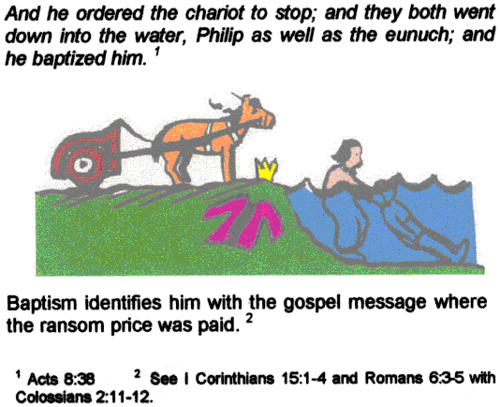
You are, then, free to sell yourself to a new master, the Lord Jesus! ₃₇
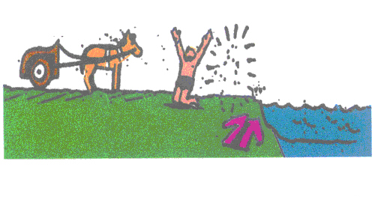
What happens, then, when you willingly sell yourself and become God’s slave? ₃₈ First, verse 15 emphasizes that you would not willingly serve your former master, sin. ₃₉ Your obedience is only to God, not the old sin life. Conversion to the Lord is a matter of where you put your focus!
III. So – Why Change Masters? – v21-23 ₄₀
The question, then, becomes why change masters? ₄₁ Verses 21 through 23 answers that question very plainly, What benefit did you reap at that time from the things you are now ashamed of? Those things result in death! But now that you have been set free from sin and have become slaves to God, the benefit you reap leads to holiness, and the result is eternal life. For the wages of sin is death, but the gift of God is eternal life in Christ Jesus our Lord. ₄₂
Verse 23 tells us it’s because of the wages! Wages, here, was the Roman military term for paycheck. A soldier was paid for risking his life. Roman law said, therefore, it could never be withheld or taken away from him. ₄₃ Sin’s “paycheck” is death! That’s the negative reason. ₄₄
Another good reason for changing masters, according to this verse, is the gift! The word “gift” implies the Roman custom of giving every soldier a bonus on the emperor’s birthday. It was a gift. The soldier didn’t earn it. ₄₅ God’s free gift to you is eternal life! That’s the positive reason. ₄₆
The final question this scripture answers for us is what’s the process for changing masters? We find that in verse 19, ₄₇ Just as you used to offer the parts of your body in slavery to impurity and to ever-increasing wickedness, so now offer them in slavery to righteousness leading to holiness. Righteousness, having a right relationship with the Lord, leads you towards holiness. ₄₈ Righteousness is the process, holiness is the goal! ₄₉ The result of the process of heading toward holiness is God’s free gift, eternal life.
Eternal life is not the goal, holiness is. It is, rather, the free gift that comes with your focus on obeying and pleasing God.
You, now, can surrender your life willingly as a slave to the One Who bought your freedom from the slavery of sin. Your life can be an expression of gratitude to the Lord for the cross.
A well-disciplined child learns to operate within well defined perimeters set by dad and mom. Obedience to God means operating your life within His well-defined perimeters. This gives you all the freedom you could want by staying within those boundaries. ₅₀
John, Chapter 8, verse 34 says, So if the Son sets you free, you will be free indeed! You see, ₅₁ you can be a slave and be free at the same time. Just surrender to the right master!

http://biblelifemessages.org/

“Free to Follow”, October 31, Our Daily Bread, RBC Ministries.
Romans 6:16.
Genesis 2:16-17.
Uπακούω.
Mark 12:23.
ὁ ποιω̂ν τὴν ἁμαρτίαν.
Romans 6:15 - What then? Shall we sin because we are not under law but under grace? By no means!
Χάρισμα.

