The Evidence of Your Salvation
Intro:
1. How do you know if God has saved you?
a. You are saved by His grace (Eph 2:8-9).
b. When you respond to that grace by repenting & being baptized, God will indwell you with His Holy Spirit (Act 2:38).
2. But what is an evidence that salvation is really happening?
1. Some say you know by the Pentecostal experience of speaking in tongues.
2. Others say it’s the sudden desire to know the Lord, study the Bible & worship Him.
3. Does the Bible give us any indications, or evidence, so we can know?

I John 4:7-15

3. v11 - God’s word says here, it’s the desire to love the Lord by loving His people!
4. ILL: Philip Bliss & “Oh, How I Love Jesus”. He realized how short his human love came in contrast to God’s love for him!
5. So - where does this love come from & what makes it an evidence of your salvation?

I. v7-12 - Where Does Love Come From?
A. v7-8 - Love begins with God.
1. This explains why God created us.
a. With all the heartbreak, rebellion & lack of response to His love for us, why did He even bother?
b. Love, to be love, needs an object. So He created you!
2. This explains why God gave you a free will.
a. Love isn’t worth much unless it is freely given.
b. So, God created evil - the very opposite of Himself - so you could have a clear cut choice.
3. This explains why God has such a personal interest in His creation.
a. The Deist Position: God could have created us & then let us alone to shift for ourselves.
b. ILL: In the movie “Oh God!” - George Burns just goes off to play with the animals.
c. But God prefers to work in & through your life!
4. This explains why God sent His Only Son to the cross!
a. Rom 6:23 - Without love, God could have left you to face the consequences of your rebellion & disobedience - death.
b. Jn 3:16 - With love, God Himself paid the price for sin so you could have eternal & abundant life.
B. v9-10 - Love was made known through Lord Jesus.
1. v9 - The Lord is the bringer of real life!
a. Are you just existing this morning without real purpose in your life?
b. If your purpose is not loving God, then it’s not the purpose He intended for you to have.
c. If you really want to come alive, switch the purpose in your life to loving Him!
2. v10 - The Lord is the restorer of your lost relationship with God!
a. God loved you first! - Rom 5:8 - But God demonstrates his own love for us in this: While we were still sinners, Christ died for us.
b. Atoning sacrifice (ἱλασμός) = lit. the “mercy seat”, expiation, propitiation, the means of forgiveness. What’s the Mercy Seat?
c. So - the fellowship that was lost in the garden was restored at the cross!
C. v12 - Love is displayed to the world through us.
1. Love is how God live in (μένω) = abides, remains, dwells; in us.
2. Complete (τελειόω) = to make perfect, complete, become mature.
3. As you express love to others your love continues to grow to maturity.
4. This makes the world sit up & take notice!

II. v13-15 - How Does Love Become
the Evidence of Your Salvation?
A. v13 - Love comes of His Spirit. Rom 5:5 - God has poured out his love into our hearts by the Holy Spirit, whom he has given us.
1. Love is the first Fruit of the Spirit (Gal 5:22).
2. Know (γινώσκω) = to know by personal experience.
3. So - If you have this fruit you can know by experience that you are remaining in Him & He is remaining in you!
B. v14-15 - Love becomes the expression of an active faith.
1. Saving faith is trusting Lord Jesus as the Son of God & your Savior.
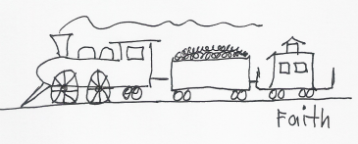

2. Putting your faith into a verbal witness (the Good Confession) makes it alive.
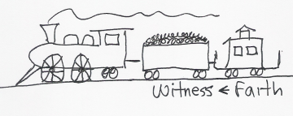

3. Putting your confession into an active love gives it power!

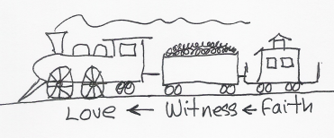
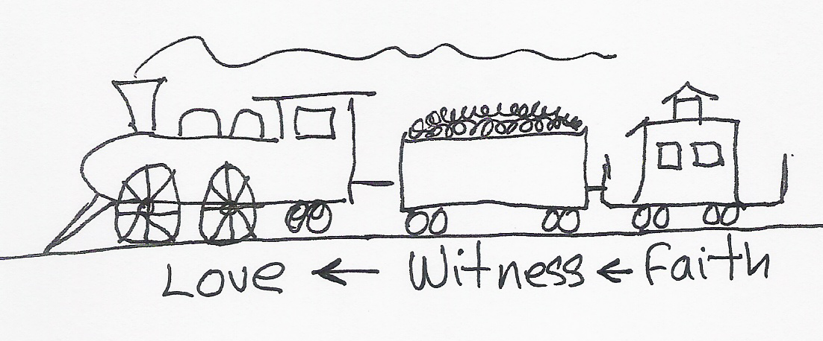

Jam 2:14-18 - What good is it, my brothers, if a man claims to have faith but has no deeds? Can such faith save him? ﻿Suppose a brother or sister is without clothes and daily food. ﻿If one of you says to him, “Go, I wish you well; keep warm and well fed,” but does nothing about his physical needs, what good is it? ﻿In the same way, faith by itself, if it is not accompanied by action, is dead. But someone will say, “You have faith; I have deeds.” Show me your faith without deeds, and I will show you my faith by what I do.

So - love becomes the evidence of your salvation
when it’s coupled to an active faith.
http://biblelifemessages.org/

