Bible life messages
The Impact of God's Word
Luke 8:4-8, 11-15

₁ The affect the word of God has on a person's life depends on the condition of their heart. When you share the gospel or your faith with someone and they don't respond, does that mean you are a failure? This passage of scripture explains why the same word of God has different affects on different people. ₂
In Luke, chapter 8, verses 4 through 8 and, then, in verses 11 through 15, it says, While a large crowd was gathering and people were coming to Jesus from town after town, he told this parable: “A farmer went out to sow his seed. As he was scattering the seed, some fell along the path; it was trampled on, and the birds of the air ate it up. Some fell on rock, and when it came up, the plants withered because they had no moisture. Other seed fell among thorns, which grew up with it and choked the plants. Still other seed fell on good soil. It came up and yielded a crop, a hundred times more than was sown.” When he said this, he called out, “He who has ears to hear, let him hear”. ₃
“This is the meaning of the parable: The seed is the word of God. Those along the path are the ones who hear, and then the devil comes and takes away the word from their hearts, so that they may not believe and be saved. Those on the rock are the ones who receive the word with joy when they hear it, but they have no root. They believe for a while, but in the time of testing they fall away. ₄
The seed that fell among thorns stands for those who hear, but as they go on their way they are choked by life’s worries, riches and pleasures, and they do not mature. But the seed on good soil stands for those with a noble and good heart, who hear the word, retain it, and by persevering produce a crop. ₅
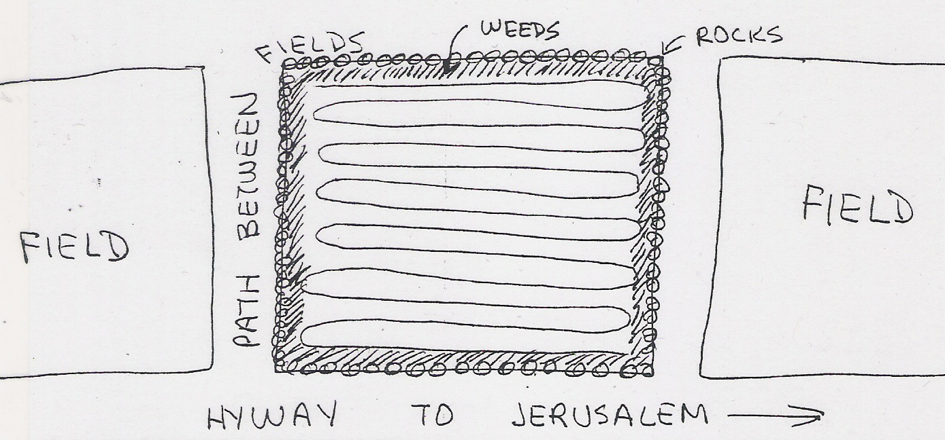
Fertile fields in the Middle East, even today, are separated by paths. Limestone rocks, plentiful in Israel, are piled in a row around the perimeter of each farmer's field. The field, within that perimeter, is plowed and fertilized in preparation for the seed. Then, the farmer, in those days, would bring a large bag of seeds to his field. He would reach into his bag, grab a handful of seed and throw the seed out on to the field prepared for it. As he spread the seed, some would fall up against the rocks, into the rocks and on the path separating his field from his neighbor's. The same seed is sown, but some of it falls on different types of ground. The same word of God may fall on different hearts. That's the picture Lord Jesus is painting for us in this parable. ₆
In verses 5 and 12 the Lord says that some of God's word falls on . . .
I. The Hard Heart - v5 & 12
The hard heart. ₇ Notice the condition of this ground. A farmer went out to sow his seed. As he was scattering the seed, some fell along the path; it was trampled on, and the birds of the air ate it up. ₈

What was the condition of the ground? The path between the fields was made hard by people continually walking on it. ₉
How did that affect the seed? As the farmer sowed the seed, some of it fell on the path remaining on the top of the ground. So, the birds would come and eat the seed.
I can remember when I tried to plant a lawn on our front yard. I got one of those tumbler type drums, the ones filled with holes, with the handle on it. I filled it with grass seed and rolled it across the yard evenly spreading the seed. Then, I stood there helplessly as I watched the neighborhood birds come and make a meal out of my nice tasty seeds. ₁₀
Maybe this describes the condition of your heart. Those along the path are the ones who hear, and then the devil comes and takes away the word from their hearts, so that they may not believe and be saved. ₁₁ Do you hear the word of God with a closed mind or an indifferent attitude? ₁₂ Are you too proud to be taught something new? ₁₃ Are you so loyal to what you have been taught in the past that you automatically reject any information that might be different? After all, what would your old teacher or preacher say? Would you still be accepted by your friends or relatives who believe the old way? This is the reason some scientists cling to the hypothesis of Evolution and can't tolerate the idea of Creation. Would you rather reject what would require you to change your life than to give up what you've been used to? Why do you suppose Nicodemus came to Jesus at night! ₁₄
In verse 6 and 13, Lord Jesus deals with . . .

II. The Shallow Heart - v6 & 13
The shallow heart. ₁₅ Notice the condition of this ground. Some fell on rock, and when it came up, the plants withered because they had no moisture. ₁₆
What was the condition of this ground? In Palestine there is hard limestone rock just a few inches beneath good dirt much like what you see in the southwest United States. The seed penetrates easily and germinates fast because the ground is warmed by the sun. ₁₇ How does that affect the seed? When the seed tries to find moisture it can't penetrate the rock, so the plant becomes scorched and dies. ₁₈
Is this the kind of heart you have? Those on the rock are the ones who receive the word with joy when they hear it, but they have no root. They believe for a while, but in the time of testing they fall away. ₁₉ Are you quick to accept new ideas but don't think things out first? ₂₀ Do you quickly accept every new idea that comes along but, then, quickly drop it for something else?
Part of the process in applying for Conscientious Objector status In the military is to have an interview with the chaplain. As an army chaplain I conducted many of these interviews. The interview questions were found in an army regulation and had to be asked exactly the way they appeared in the book. The candidate's answers were recorded and the chaplain had to determine the sincerity of those answers. Some of the candidates were genuinely convinced that it was morally wrong for them to kill in combat. They came to that conclusion after they had committed themselves to Uncle Sam. Others were using this application simply to get out of the army or get into what they thought would be a plush assignment. But most were like Pliable in Paul Bunyan's Pilgrim's Progress. They simply jumped from one conviction to another without thinking through the implication of their choices.
Sometimes people get an emotional high when they are baptized, but when their feelings calm down, they get discouraged with their faith. As a young pastor I had a ministry with a group of young enthusiastic former hippies.
There was an influx of rejection of God and all moral values among college aged young folks during the late 1960's called the hippy movement. The participants called themselves, among other names, "beatniks". They abused themselves with unlimited drugs, alcohol and sex.
Some began to realize the emptiness in their lives and found the answer in the Lord Jesus. Another movement sprang up, a Christian one, called the Jesus Movement. Participants claimed to have been miraculously cured of their former abuses and were very excited about their personal relationship with the living Lord! This movement flourished as well. But much like their former life, when the emotional high began to subside, they began to experience a spiritual depression.
This is when Linda and I stepped in to help them establish their relationship with the Lord on the more solid foundation of faith based upon God's word. We helped give them more depth to their shallow hearts by moving them from the rocky to the fertile ground. ₂₁
The next type of heart is found in verse 7 and verse 14.
III. The World Oriented Heart - v7 & 14
The world oriented heart. ₂₂ Notice the condition of this ground. Other seed fell among thorns, which grew up with it and choked the plants. ₂₃ What was the condition of this ground? This was tilled ground along the edge of the field, next to the rock wall. It looks deceptive because the seed falls next to churned up grass, weeds and old roots. ₂₄
How did that affect the seed? Old weeds germinate faster than the good seed and choke out much of it in the process. ₂₅
Does that resemble the condition of your heart? The seed that fell among thorns stands for those who hear, but as they go on their way they are choked by life’s worries, riches and pleasures, and they do not mature. ₂₆ Do you allow the world's interests to crowd out the word of God in your heart? ₂₇
Life's worries, in the original language, means "care", "anxiety". ₂₈ In Matthew, chapter 6, verses 26 through 30, Lord Jesus told us not to be anxious about food or clothing. Look at the birds of the air; they do not sow or reap or store away in barns, and yet your heavenly Father feeds them. Are you not much more valuable than they? Who of you by worrying can add a single hour to his life? ₂₉
“And why do you worry about clothes? See how the lilies of the field grow. They do not labor or spin. Yet I tell you that not even Solomon in all his splendor was dressed like one of these. If that is how God clothes the grass of the field, which is here today and tomorrow is thrown into the fire, will he not much more clothe you, O you of little faith. ₃₀
Riches, in the original language, means "wealth". This is when your focus in life is geared to obtaining money. ₃₁
Pleasures, means "lust" and "sensual ideas". This is the attitude of wanting to get as much pleasure out of life as possible. John Denver died when he crashed the experimental airplane he had just purchased in the Pacific Ocean in 1997 at the age of 53. His wife, Annie, commented at his funeral, "John lived his life to the fullest". ₃₂
These worldly interests don't have to be bad ones. They just need to have more priority in your life than the Lord does! Remember the biblical story of Mary and Martha. Jesus was in the living room teaching His disciples. Mary was sitting at His feet listening to every word while her sister, Martha, was in the kitchen preparing a meal for her guests. Martha got upset about doing all of the work herself while Mary sat idle. Lord Jesus had to point out to her that being a good hostess was nice but giving Him complete attention was better. If you are too busy with good things to pray and study your Bible; you're too busy! Too many good and worthwhile things can crowd out the best and most worthwhile. ₃₃
The final type of heart mentioned in this parable is . . .
IV. The Receptive Heart - v8 & 15
The receptive heart found in verses 8 and 15. ₃₄ It's important to see the condition of this ground. Still other seed fell on good soil. It came up and yielded a crop, a hundred times more than was sown. ₃₅ What was the condition of this ground? The good ground was deep, clean and fertile. ₃₆
How did it affect the seed? The seed that grew there multiplied a hundred times! ₃₇
But the seed on good soil stands for those with a noble and good heart, who hear the word, retain it, and by persevering produce a crop. Hopefully, that's the condition of your heart! ₃₈ Do you listen to the word of God with an open mind and a willing heart? ₃₉ Are you willing to learn or do you already know it all? ₄₀
Are you prepared to hear? You know, studying your Bible throughout the week prepares you to receive what you get on Sundays more. Are you ever too tired, too busy or too proud to really hear? ₄₁
Do you understand and put into action what you hear? ₄₂ The Bible puts it this way in James, chapter 2, verses 14 through 17, What good is it, my brothers, if a man claims to have faith but has no deeds? Can such faith save him? Suppose a brother or sister is without clothes and daily food. If one of you says to him, “Go, I wish you well; keep warm and well fed,” but does nothing about his physical needs, what good is it? In the same way, faith by itself, if it is not accompanied by action, is dead. ₄₃
You have no idea how much good your Christian witness can be! Obviously most of the good seed fell into the fertile ground that was prepared for it or the farmer wouldn't have bothered to do it.
So, tell the good news anyhow, even if many people don't respond. Some will. ₄₄
Remember this: all will be affected somehow by your prayer saturated witness! Isaiah reminds you, As the rain and the snow come down from heaven, and do not return to it without watering the earth and making it bud and flourish, so that it yields seed for the sower and bread for the eater, so is my word that goes out from my mouth: It will not return to me empty, but will accomplish what I desire and achieve the purpose for which I sent it.
biblelifemessages.org

v4-8.
v11-13.
v12-15.
v5.
v12.
v6.
v13.
v7.
v14.
μέριμνα.
πλοῦτος.
ἡδονή.
Luke 10:38-42.
v8.
v15.
Isaiah 55:10-11.

