Bible life messages
How Can Real Thanksgiving Be Expressed?
Luke 17:11-19

₁ Thanksgiving Day was proclaimed by President Abraham Lincoln on October 3, 1863 to be the last Thursday in November. This was in response to a letter he received from Sarah Josepha Hale, a 74-year-old magazine editor, early in 1863. She urged him to set aside a day to be a “National and fixed Union Festival”.
Here is the Proclamation: “The year that is drawing towards its close, has been filled with the blessings of fruitful fields and healthful skies. To these bounties, which are so constantly enjoyed that we are prone to forget the source from which they come, others have been added, which are of so extraordinary a nature, that they cannot fail to penetrate and soften even the heart which is habitually insensible to the ever watchful providence of Almighty God. In the midst of a civil war of unequalled magnitude and severity, which has sometimes seemed to foreign States to invite and to provoke their aggression, peace has been preserved with all nations, order has been maintained, the laws have been respected and obeyed, and harmony has prevailed everywhere except in the theatre of military conflict; while that theatre has been greatly contracted by the advancing armies and navies of the Union. Needful diversions of wealth and of strength from the fields of peaceful industry to the national defense, have not arrested the plough, the shuttle or the ship; the axe has enlarged the borders of our settlements, and the mines, as well of iron and coal as of the precious metals, have yielded even more abundantly than heretofore. Population has steadily increased, notwithstanding the waste that has been made in the camp, the siege and the battlefield; and the country, rejoicing in the consciousness of augmented strength and vigor, is permitted to expect continuance of years with large increase of freedom. No human counsel hath devised nor hath any mortal hand worked out these great things. They are the gracious gifts of the Most High God, who, while dealing with us in anger for our sins, hath nevertheless remembered mercy. It has seemed to me fit and proper that they should be solemnly, reverently and gratefully acknowledged as with one heart and one voice by the whole American People. I do therefore invite my fellow citizens in every part of the United States, and also those who are at sea and those who are sojourning in foreign lands, to set apart and observe the last Thursday of November next, as a day of Thanksgiving and Praise to our beneficent Father who dwelleth in the Heavens. And I recommend to them that while offering up the ascriptions justly due to Him for such singular deliverances and blessings, they do also, with humble penitence for our national perverseness and disobedience, commend to His tender care all those who have become widows, orphans, mourners or sufferers in the lamentable civil strife in which we are unavoidably engaged, and fervently implore the interposition of the Almighty Hand to heal the wounds of the nation and to restore it as soon as may be consistent with the Divine purposes to the full enjoyment of peace, harmony, tranquility and Union.
In testimony whereof, I have hereunto set my hand and caused the Seal of the United States to be affixed.
Done at the City of Washington, this Third day of October, in the year of our Lord one thousand eight hundred and sixty-three, and of the Independence of the United States the Eighty-eighth.
By the President: Abraham Lincoln”
When you are grateful to the Lord how can real thanksgiving be expressed?
The Bible gives us an event to help us answer that question. ₂
In Luke, chapter 17, verses 11-19 we read, Now on his way to Jerusalem, Jesus traveled along the border between Samaria and Galilee. As he was going into a village, ten men who had leprosy met him. They stood at a distance and called out in a loud voice, “Jesus, Master, have pity on us!” When he saw them, he said, “Go, show yourselves to the priests.” And as they went, they were cleansed. ₃
One of them, when he saw he was healed, came back, praising God in a loud voice. He threw himself at Jesus’ feet and thanked him — and he was a Samaritan. Jesus asked, “Were not all ten cleansed? Where are the other nine? Was no one found to return and give praise to God except this foreigner?” Then he said to him, “Rise and go; your faith has made you well.” ₄
The first answer is in verses 12 and 13.
I. It’s Okay to Ask for Divine Healing - v12-13
It’s okay to ask for diving healing. ₅
These men had an incurable disease. Verse 12, As he was going into a village, ten men who had leprosy met him. ₆
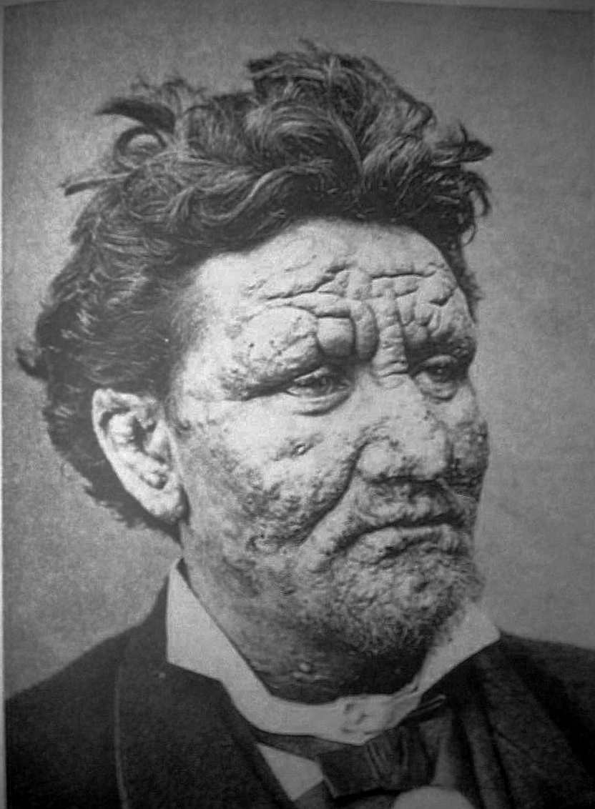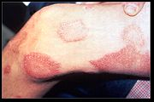
Leprosy, in the original language, was a common word for several diseases of the skin. The most common form in the Bible was a severe psoriasis. Some believe it was Hansen’s Disease.
We have a few Bible examples. ₇
Moses was struck with it before the fiery bush. Then the LORD said, “Put your hand inside your cloak.” So Moses put his hand into his cloak, and when he took it out, it was leprous, like snow. “Now put it back into your cloak,” he said. So Moses put his hand back into his cloak, and when he took it out, it was restored, like the rest of his flesh. ₈
Miriam experienced it when she spoke against Moses’ authority. ₉ Second Kings, chapter 5, verses 1 through 14 records that Naaman had leprosy when he came to be cured by Elisha. ₁₀
In verse 12, these lepers obeyed the commands of God; the Law of Moses! ₁₁ How do we know? It says they stood at a distance. ₁₂
They probably obeyed the rest of the Law of Moses as well! Leviticus, chapter 13, verses 45 and 46, The person with such an infectious disease must wear torn clothes, let his hair be unkempt, cover the lower part of his face and cry out, ‘Unclean! Unclean!’ As long as he has the infection he remains unclean. He must live alone; he must live outside the camp. ₁₃
We have the examples of others who asked to be healed. ₁₄
There was the man in Matthew, chapter 8; ₁₅ Blind Bartimaeus; ₁₆ and the royal official’s son in John, chapter 4. ₁₇
In verse 17 we discover that they all believed Jesus had the power to heal them. The all cried out to Jesus with a loud voice! They stood at a distance and called out in a loud voice, “Jesus, Master, have pity on us!” ₁₈ The same word is also used in verse 15 when the Samaritan praised God. ₁₉
What provided their healing? Verse 19 says, Then he said to him, “Rise and go; your faith has made you well.”
The second question is answered in verse 14 . . . ₂₀
II. It’s Okay to Expect
Results from Your Prayers - v14
It’s okay to expect results from your prayers! Verse 14 says, When he saw them, he said, “Go, show yourselves to the priests.” And as they went, they were cleansed. ₂₁ They obeyed the Lord who told them to show themselves to the priests. ₂₂
To be restored to society, if they were cured or beyond the contagious stage, they had to show themselves to the priests and offer special sacrifices. ₂₃ They would be inspected by the priests and anointed if found ceremonially “clean”. ₂₄
Another way we know they expected results was they started toward the temple before they were healed! Verse 14 says, as they went, they were cleansed! ₂₅
So, pray expectantly by thanking the Lord in advance! That’s praying in faith! ₂₆
Then there’s the final answer here to the question, how can real thanksgiving be expressed?
III. It’s Okay to be Demonstrative in
Expressing Your Gratitude - v15-18
It’s okay to be demonstrative in expressing your gratitude! ₂₇
This man expressed his gratitude enthusiastically! Notice verses 15 and 16, One of them, when he saw he was healed, came back, praising God in a loud voice. He threw himself at Jesus’ feet and thanked him — and he was a Samaritan. ₂₈ He shouted his praises with a loud voice, the same word as in verse 13! ₂₉ He, then, threw himself at Jesus’ feet! ₃₀
The final thought here, though, is the Lord had expected to be thanked! Observe verses 17 and 18, Jesus asked, “Were not all ten cleansed? Where are the other nine? Was no one found to return and give praise to God except this foreigner?”
It’s just plain discourteous not to say “thank you” when receiving a gift or a favor, right? ₃₁ This man was the least expected to show gratitude because he was a Samaritan (verse 16) and a foreigner (verse 18)! ₃₂
So, to please the Lord, talk to Him often! Show your gratitude to Him for what He has done for you.
He deserves it!

http://www.biblelifemessages.org

Luke 17:11-14.
Luke 17:15-19.
λεπρός.
Exodus 4:6-7.
Numbers 12:9-16 - The anger of the Lord burned against them, and he left them. When the cloud lifted from above the Tent, there stood Miriam — leprous, like snow. Aaron turned toward her and saw that she had leprosy; ¹¹ and he said to Moses, “Please, my lord, do not hold against us the sin we have so foolishly committed. Do not let her be like a stillborn infant coming from its mother’s womb with its flesh half eaten away.” So Moses cried out to the Lord, “O God, please heal her!” The Lord replied to Moses, “If her father had spit in her face, would she not have been in disgrace for seven days? Confine her outside the camp for seven days; after that she can be brought back.” So Miriam was confined outside the camp for seven days, and the people did not move on till she was brought back. After that, the people left Hazeroth and encamped in the Desert of Paran.
Matthew 8:1-3 - When he came down from the mountainside, large crowds followed him. A man with leprosy came and knelt before him and said, “Lord, if you are willing, you can make me clean.” Jesus reached out his hand and touched the man. “I am willing,” he said. “Be clean!” Immediately he was cured of his leprosy.
Mark 10:46-52 - Then they came to Jericho. As Jesus and his disciples, together with a large crowd, were leaving the city, a blind man, Bartimaeus (that is, the Son of Timaeus), was sitting by the roadside begging. When he heard that it was Jesus of Nazareth, he began to shout, “Jesus, Son of David, have mercy on me!” Many rebuked him and told him to be quiet, but he shouted all the more, “Son of David, have mercy on me!” Jesus stopped and said, “Call him.” So they called to the blind man, “Cheer up! On your feet! He’s calling you.” Throwing his cloak aside, he jumped to his feet and came to Jesus. “What do you want me to do for you?” Jesus asked him. The blind man said, “Rabbi, I want to see.” “Go,” said Jesus, “your faith has healed you.” Immediately he received his sight and followed Jesus along the road.
John 4:46-54 - Once more he visited Cana in Galilee, where he had turned the water into wine. And there was a certain royal official whose son lay sick at Capernaum. When this man heard that Jesus had arrived in Galilee from Judea, he went to him and begged him to come and heal his son, who was close to death. “Unless you people see miraculous signs and wonders,” Jesus told him, “you will never believe.” The royal official said, “Sir, come down before my child dies.” Jesus replied, “You may go. Your son will live.” The man took Jesus at his word and departed. While he was still on the way, his servants met him with the news that his boy was living. When he inquired as to the time when his son got better, they said to him, “The fever left him yesterday at the seventh hour.” Then the father realized that this was the exact time at which Jesus had said to him, “Your son will live.” So he and all his household believed. This was the second miraculous sign that Jesus performed, having come from Judea to Galilee.
φωνή.
φωνή.
Luke 17:15-16 - One of them, when he saw he was healed, came back, praising God in a loud voice. He threw himself at Jesus’ feet and thanked him — and he was a Samaritan.

