Bible life messages
The Free Wash Job
Matthew 8:1-4

₁ Our youth group at the church decided to wash cars as a fundraising project to provide partial scholarships for some of them to attend a week at a Christian Summer Camp. So, our church members lined up their cars for the youth group to wash. The cars got a good wash job, but it wasn’t free; a donation was expected.
Matthew, chapter 8, verses 1 through 4 tell us about another wash job, provided by the Lord on the cross that is free! ₂
When he came down from the mountainside, large crowds followed him. A man with leprosy came and knelt before him and said, “Lord, if you are willing, you can make me clean.” Jesus reached out his hand and touched the man. “I am willing,” he said. “Be clean!” Immediately he was cured of his leprosy. Then Jesus said to him, “See that you don’t tell anyone. But go, show yourself to the priest and offer the gift Moses commanded, as a testimony to them.”
Let me show you how the Lord’s healing of this leper and His healing for you spiritually compare. ₃
Notice . . .
I. The Condition – v2
The condition. The Bible says this man had leprosy.
So, what is leprosy? ₄
The most common variety today is called Hansen’s Disease. ₅
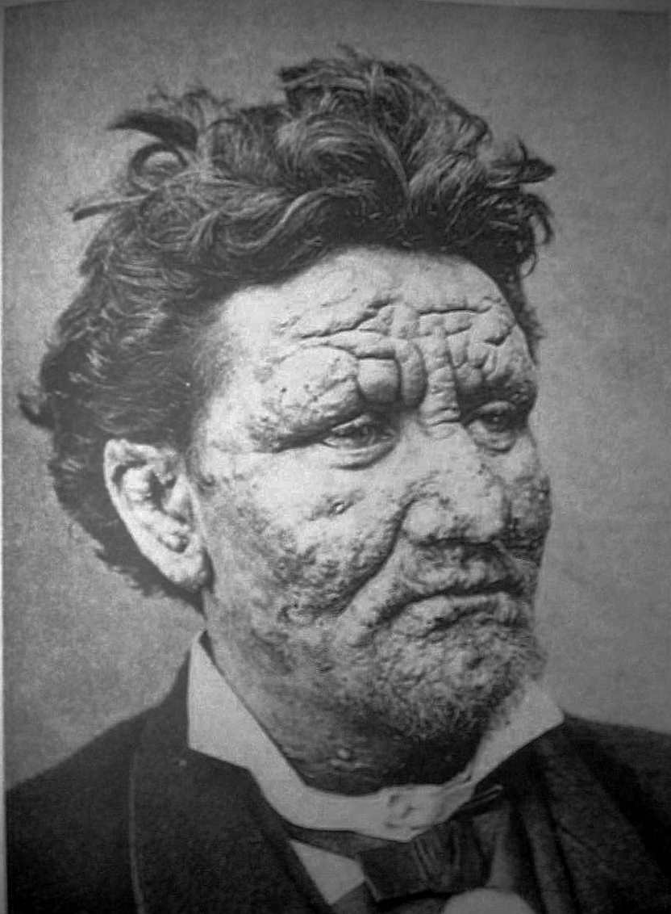
Sores begin to spread over the entire body.
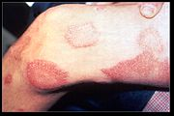
Bones and nerves are affected causing much pain and deformity. The head and face take on a lion like appearance. Death occurs within ten years. ₆
The Bible variety was probably much like this. ₇
The word for “leprosy” in the original language was a common word for a skin disease. This man could have had one of a number of diseases we have identified today. ₈
The Old Testament Law of Moses required people who had this condition to be quarantined. They had to cover their whole body, stand at least six feet away from everyone and cry out “unclean”. ₉
Gradually, when all the skin turned white, the person could be inspected by a priest and pronounced “clean”.
There are other examples in the Bible of people who had leprosy. ₁₀
When Moses was on Mount Sinai before the Lord in the burning bush, God gave him leprosy briefly as a sign that God was directing him. ₁₁
God inflicted Mariam, Moses’ sister, with leprosy to impress her that God was directing her brother. ₁₂
And, then, there was General Naaman, asked the prophet Elisha to heal him. He was healed, but only after dipping himself seven times in the muddy Jordan River in obedience to God’s command. ₁₃
Now, notice verse 2. A man with leprosy came and knelt before him and said, “Lord, if you are willing, you can make me clean.” He didn’t doubt the Lord’s ability to heal him; only His willingness! What faith! Only one other time was leprosy ever cured. That was General Naaman. This man was full of leprosy. It was in its advanced stages; a hopeless situation! ₁₄
Leprosy and sin can be compared.
Leprosy is ugly. ₁₅ So is sin. ₁₆
Leprosy separated a person from society. ₁₇ Sin separates you from God and godly people! ₁₈
Restoration can happen to a leper when they are inspected and considered “white”. With leprosy fellowship is found when the priest declares him “all white”. ₁₉ Divine deliverance comes as the Lord’s blood shed, on the cross, washes you “white as snow”! ₂₀
Next, in verse 3, we have . . .
II. The Cleansing - v3
The cleansing. ₂₁ Jesus reached out his hand and touched the man. “I am willing,” he said. “Be clean!” Immediately he was cured of his leprosy. Jesus stretched forth His hand making fellowship and service possible. ₂₂
Jesus did what no one else would dare to do; He touched a leper! ₂₃ Only the high priest had the legal right to touch a leper; and, then, only after the leper was inspected and considered clean. ₂₄
Jesus expressed His desire to heal by echoing the leper’s request if you are willing with I am willing! ₂₅ As a result of the touch and the command Be clean, the leprosy was washed away! ₂₆
Jesus died on the cross making fellowship and service possible! ₂₇
Sin stands as a barrier between you and God. ₂₈
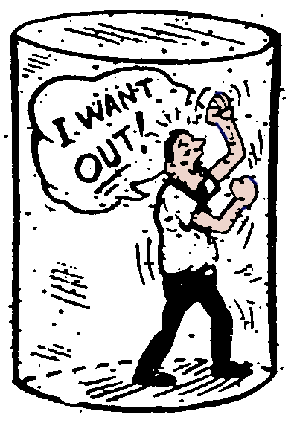

The cross breaks down that barrier by paying the price for your sin!
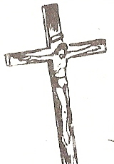
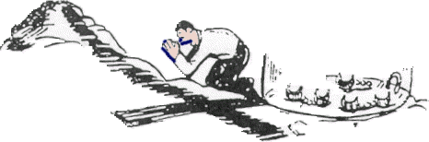
Verse 2 was the condition; a helpless leper. Verse 3 was the cleansing. ₂₉
Now, in verse 4, is . . .

III. The Command - v4
The command. Verse 4 says, Then Jesus said to him, “See that you don’t tell anyone. But go, show yourself to the priest and offer the gift Moses commanded, as a testimony to them.” ₃₀
The leper had to restore himself by obeying what God told him to do. ₃₁ He was cleansed, but not legally restored! ₃₂ The Law of Moses declared that he must go to the priest, be inspected and be declared clean. Then he had to prepare the appropriate thank offering. ₃₃
The cleansed sinner must restore himself by obeying what the Bible tells him to do. ₃₄ The blood of Jesus shed on the cross makes fellowship and service possible, but only personal obedience makes it real! ₃₅
The biblical response for the cleansed sinner is to Repent and be baptized, every one of you, in the name of Jesus Christ for the forgiveness of your sins. So, what are you waiting for? Get up, be baptized and wash your sins away, calling on his name. ₃₆
The cleansing of Naaman was a foreshadow of the cleansing of sin. Save yourselves from this corrupt generation. ₃₇
Lord Jesus provided for your free wash job when He died on the cross! Now, come and receive it. Be cleansed!

http://biblelifemessages.org

λέπρα.
Exodus 4:6-7 - Then the Lord said, “Put your hand inside your cloak.” So Moses put his hand into his cloak, and when he took it out, it was leprous, like snow. “Now put it back into your cloak,” he said. So Moses put his hand back into his cloak, and when he took it out, it was restored, like the rest of his flesh.
Numbers 12:9-10 - The anger of the Lord burned against them, and he left them. When the cloud lifted from above the Tent, there stood Miriam — leprous, like snow. Aaron turned toward her and saw that she had leprosy . . .
II Kings 5:1-14.
Luke 5:12 - While Jesus was in one of the towns, a man came along who was covered with leprosy.
Revelation7:9-14.
Leviticus 14:1-32.
Acts 2:38.
Acts 22:16.
Acts 2:40.

