Bible life messages
How to Be a Lighthouse
Matthew 5:14-16

₁ Our scripture today talks about disciples of Christ being a lighthouse. ₂
Matthew, chapter 5, verses 14 through 16, says, You are the light of the world. A city on a hill cannot be hidden. Neither do people light a lamp and put it under a bowl. Instead they put it on its stand, and it gives light to everyone in the house. In the same way, let your light shine before men, that they may see your good deeds and praise your Father in heaven.
What does letting your light shine before men mean to you? It certainly means doing your good deeds because that’s what this passage says. What are other ways to let your light shine?
1. Witnessing as a way of life?
2. Attending regular Sunday services and ministries, ministry team meetings, Christian conventions, church workdays and other Christian events.
3. As a church, it means ministries we do together like mission trips, Halloween Night at the church and Thanksgiving Day community suppers.
Several years ago, when I was a pastor in Fremont, California, many of us pastors organized a Christian community project. We called it the Fremont Lighthouses of Prayer Movement. We had enough success with this plan that Christians from several states came to a conference we held to find out what we did.
Here's the plan. This is what was involved. ₃ I have revised it to fit better into my ministry.
The first question is . . .

I. What’s a Lighthouse?
What’s a lighthouse? ₄
Lighthouses give out light!
You’ve seen them, either in person or in pictures. They are usually built on mounds that overlook the seashore. They send out strong beams of light across the ocean that can be seen by ships for miles. Their purpose is to let the ships know where dangerous land is, so they won’t wreak on the shore or cliffs. ₅
What does light do for you? ₆
Light gives life.
As a basic ingredient of chlorophyll, light enables plants to grow. Without plants you wouldn’t have food.
Just as we need food to survive physically, you need spiritual life. Lord Jesus came to give you that life. He said, The thief comes only to steal and kill and destroy; I have come that they may have life, and have it to the full. ₇
Light also causes growth.
Plants need light to grow and bear fruit.
The word of God produces the Fruit of the Spirit!
Lord Jesus told the story of the interaction the word of God has on human free will. A farmer threw seed onto his field, and it landed on different types of ground. Most of it fell where it was supposed to fall, on the fertile land prepared for it. But, some of it landed on the rocks, the hard path outside the perimeter of the field and against the stone wall where the weeds grew. The seed didn’t do well except in the field that was prepared for it. It eventually yielded sixty and a hundred times what was planted.
People need the light provided by the word of God to grow spiritually and produce spiritual fruit. That’s one reason why they need you as a spiritual lighthouse. ₈
Lighthouses provide direction!
The Pharos of Alexandria, in ancient Egypt, was one of the ancient Wonders of the World. It was constructed by Alexander the Great in 332 B.C.
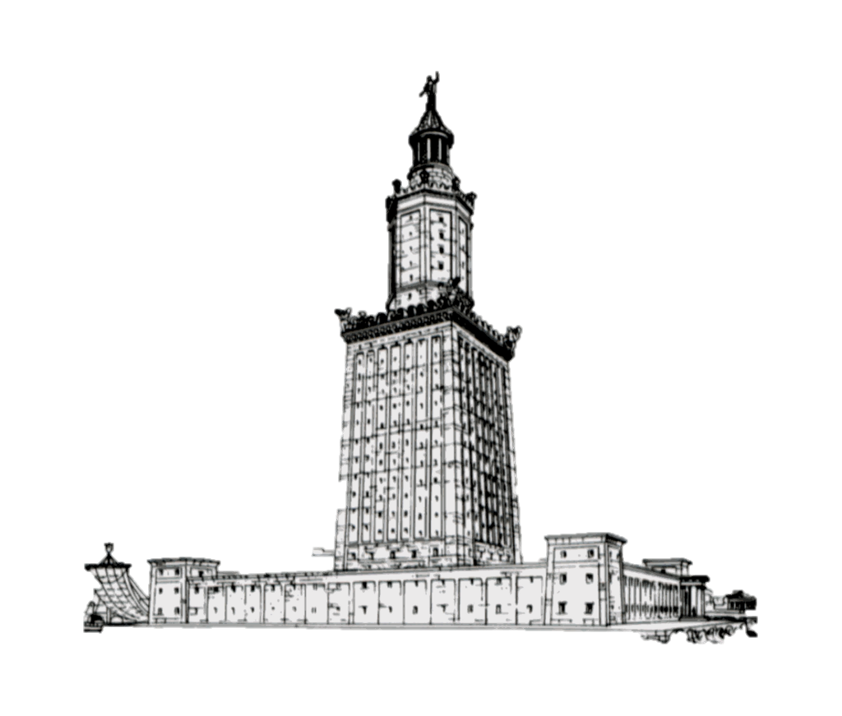
Since the seventh century B.C., lighthouses have been guiding ships out of danger. ₉
Lord Jesus said, Then you will know the truth, and the truth will set you free. People need the direction God’s light can provide. That’s another reason why they need you as a spiritual lighthouse. ₁₀

II. How Can You Be a Lighthouse?
How can you be a lighthouse? ₁₁
How does this work? ₁₂
The Lord was the original lighthouse. ₁₃ John, chapter 8, verse 12, says, When Jesus spoke again to the people, he said, “I am the light of the world. Whoever follows me will never walk in darkness, but will have the light of life.” ₁₄
Then, the Lord turned to His disciples and said, You are the light of the world. ₁₅ As the moon reflects the light of the sun, so you and I are to reflect the light of the Lord in our lives! ₁₆
You can be a lighthouse by establishing your perimeter of faith. ₁₇
What is a perimeter?
When military units set up a base camp, they establish a perimeter of defense. ₁₈
How do you establish a perimeter of faith? Decide who you will focus on for routine prayer. ₁₉
You establish your perimeter by deciding how many families on your street you will pray for: ₂₀ or, maybe, the employees in your workplace; ₂₁ or your social contacts; ₂₂ or, maybe, your family or close friends. You establish your perimeter by learning those people’s name and writing them down. ₂₃
You can be a lighthouse by preparing for your “perimeter people’s” salvation. How? ₂₄
You can start out by writing them a note and referring them to my websites: https://connectionwithgod.org and https://biblelifemessages.org.
The first website will show them how to establish a personal relationship with the Lord by a twenty-eight-minute presentation of the gospel message with an invitation at the end of it. It is designed to be used by people who want to share the gospel with others but feel inadequate. This is a useful tool you can use. There are also links to other websites to provide answers to difficult questions that might be asked.
The second website can provide discipleship tools to help new Christians grow in their new faith. It contains short messages from the Bible about issues you and others might have as you begin putting God’s will first in your lives. ₂₅
You can be a lighthouse by getting personally acquainted with your “perimeter people”. ₂₆ Tell them you are praying for them and ask them about prayer needs. ₂₇
But – what do you do if you are too shy to approach your “perimeter people”? ₂₈
Use the “Stealth Method”! You don’t have to be a people person. Some of us have trouble just going up to people and being assertive with them. You may have to express your love for them more passively. ₂₉
Write them the note stating that you are praying for your neighbors and ask if they have specific prayer concerns. Leave whatever contact information in the note you feel comfortable with. ₃₀ Then – disappear! ₃₁
You can be a lighthouse by consistently praying for each perimeter person. You can do this by “prayer walking”. ₃₂
How do you prayer walk? ₃₃ On a regular basis, walk your perimeter, stand as close to your prayer person as you feel comfortable and pray for them. Then, walk to the next location. ₃₄
Pray for these people during your prayer time and devotions. I do this every morning. Whatever time you choose, be consistent. ₃₅ Pray especially for their felt needs; the ones they tell you about or you observe. ₃₆
Look for the opportunities to witness to them that the Lord obviously points out to you. ₃₇
Ask them what they thought of the websites. ₃₈
Ask them if they have any questions you can answer. ₃₉
Live your life consistent with the faith you have. ₄₀
You can be a lighthouse by sharing your faith as the Lord provides that opportunity. ₄₁
Ask that the Lord will provide you with “Divine Encounters”. After you have become friends with your perimeter people, hopefully they will begin to trust you. Divine encounters are that these people will come to you with questions. ₄₂ First Peter, chapter 3, verse 15, states, But in your hearts set apart Christ as Lord. Always be prepared to give an answer to everyone who asks you to give the reason for the hope that you have. Prepare yourself in advance to share with them that hope! ₄₃
How do you give that answer? ₄₄
Talk about how the Lord has made a difference in your life. ₄₅
Talk about the victories in your life and the failures where the Lord helped you through them. ₄₆
Talk about the joy you have in looking forward to eternal life in heaven! ₄₇
Talk about the victories others that you know about have had in their lives! ₄₈
Would you dare to be a lighthouse for the Lord Jesus?
Would you commit yourself to trying to be His ambassador?

http://www.biblelifemessages.org

John 10:10.
Matthew 13:2-23.
Image is a drawing by Archaeologist Hermann Thiersch in 1909.
John 8:32.
Matthew 5:14.

