Bible life messages
Let the Parade Begin
Matthew 21:1-14

₁ Our scripture today will be describing the Lord’s triumphal entry into Jerusalem to begin His passion week. Before I share God’s word some historical background will give you a better understanding of the passage we will be examining. ₂
I. What is the Historical Background?
The period of time between the writing of the Old Testament and the New Testament is called the Intertestamental Period. There are two historical volumes written about this period of time called First and Second Maccabees that I will refer to for part of this background explanation. ₃
Alexander the Great dies in 323 BC. He never announced his successor to his throne. ₄ So, his five generals kill all his living heirs and divide the empire among themselves.
Our part of this history takes place between Syria and Egypt with Egyptian vassal state Palestine the buffer between them. The rulers are the sons of the original generals. ₅
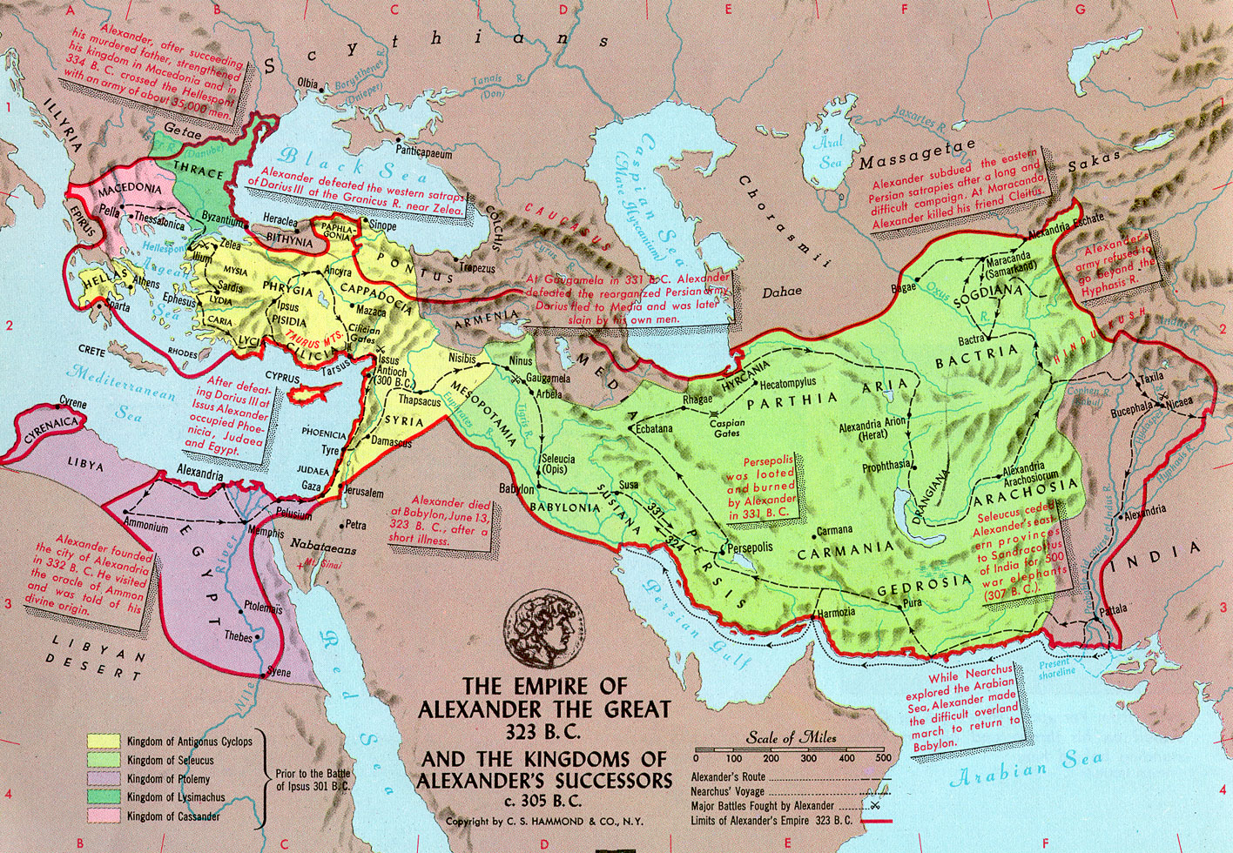
The first Syrian/Egyptian War results in a partial victory for Syria and its ruler Antiochus III. To please Rome, the rapidly forming superpower to the west, Antiochus leaves Egypt autonomous but takes some Egyptian territory as spoils. Palestine is one of the territories. ₆
After the Syrian king dies, his son, Antiochus IV, becomes the ruler. The Second Syrian/Egyptian War begins because Antiochus wants to completely conquer Egypt and rule it.
On the way to Egypt the army is halted by one man, the ambassador from Rome. He tells the king that Egypt is now an ally of Rome, and his attack would result in a war with Rome! ₇
Extremely angry, Antiochus begins his return home to sulk. On the way he hears of the Jewish civil war taking place in Jerusalem, the capital of his vassal state. He and his battle prepared soldiers, armed to the teeth, march towards Jerusalem lining the highways with crosses. On the crosses are pro Egyptian and rebellious traditional Jewish men. He ransacks Jerusalem, sets up a pro Greek (Hellenizer) high priest and proceeds to the temple. In the temple he takes all the valuable items, erects a statue to the great god Zeus and turns the temple courtyards into public brothels. ₈ He, then, commits “the abomination of desolation”, forbidding traditional animal sacrifices and offering pigs on the altar of sacrifice.
This act fulfills the prophesies of Daniel. ₉ His armed forces will rise up to desecrate the temple fortress and will abolish the daily sacrifice. Then they will set up the abomination that causes desolation . . . From the time that the daily sacrifice is abolished and the abomination that causes desolation is set up, there will be 1,290 days. ₁₀
Lord Jesus also predicts a similar tragedy, in the Gospel of Matthew, in reference to the destruction of Jerusalem by General Titus and the Romans in 70 AD! This prediction is also found in Mark. As a result, when Christians heard of what was happening in the temple at that time, they fled to the mountains around Pella and were spared.
Back to the historical background; this desecration of the temple resulted in the Maccabean Revolt. ₁₁ In 164 BC the Jews took back the temple, cleansed it and rededicated it! Joyous people flocked to Jerusalem with palm branches to clean the city and the temple. ₁₂
Hanukkah, the Jewish Feast of Lights, commemorating this event, is observed to this day!
Now here is our scripture for the day. ₁₃
As they approached Jerusalem and came to Bethphage on the Mount of Olives, Jesus sent two disciples, saying to them, “Go to the village ahead of you, and at once you will find a donkey tied there, with her colt by her. Untie them and bring them to me. If anyone says anything to you, tell him that the Lord needs them, and he will send them right away. ₁₄
This took place to fulfill what was spoken through the prophet: ‘See, your king comes to you, gentle and riding on a donkey, on a colt, the foal of a donkey.’ The disciples went and did as Jesus had instructed them. They brought the donkey and the colt, placed their cloaks on them, and Jesus sat on them. A very large crowd spread their cloaks on the road, while others cut branches from the trees and spread them on the road. ₁₅
The crowds that went ahead of him and those that followed shouted, “Hosanna to the Son of David!” “Blessed is he who comes in the name of the Lord!” “Hosanna in the highest!” When Jesus entered Jerusalem, the whole city was stirred and asked, “Who is this?” The crowds answered, “This is Jesus, the prophet from Nazareth in Galilee.” ₁₆
Jesus entered the temple area and drove out all who were buying and selling there. He overturned the tables of the money changers and the benches of those selling doves. It is written, he said to them, ‘My house will be called a house of prayer,’ but you are making it a ‘den of robbers.’ The blind and the lame came to him at the temple, and he healed them. ₁₇
II. The Triumphal Entry into Jerusalem ₁₈
Lord Jesus presents Himself as the Messiah. (v1-11) ₁₉ He does this by riding on the donkey colt. ₂₀
Verses 4 and 5, This took place to fulfill what was spoken through the prophet: ‘See, your king comes to you, gentle and riding on a donkey, on a colt, the foal of a donkey.’ This was in fulfillment of Zechariah, chapter 9, verse 9, Rejoice greatly, O Daughter of Zion! Shout Daughter of Jerusalem! See, your king comes to you, righteous and having salvation, gentle and riding on a donkey, on a colt, the foul of a donkey. ₂₁ The subject here is the king. In this context he is the Messiah King! ₂₂ Righteous and having salvation, is omitted in Matthew, but is what the Messiah would provide for us! ₂₃
It was miraculous! Can you imagine riding on an unbroken colt? Think cowboys in western movies. ₂₄
Lord Jesus is a gentle king! The word Gentle means humble, not proud. He presented Himself as a king of peace, not war! ₂₅
The crowd received Lord Jesus as a king by spreading their cloaks before Him. Verse 7 and 8, They brought the donkey and the colt, placed their cloaks on them, and Jesus sat on them. A very large crowd spread their cloaks on the road, while others cut branches from the trees and spread them on the road. ₂₆ This happened when Jehu was proclaimed king. ₂₇ It also happened when Simon Maccabees entered triumphantly into Jerusalem to cleanse the city and the temple. ₂₈
The crowd received Lord Jesus as a king by shouting Hosanna! ₂₉ Verse 9, The crowds that went ahead of him and those that followed shouted, “Hosanna to the Son of David!” “Blessed is he who comes in the name of the Lord!” “Hosanna in the highest!” This means “Save us now!” This was a cry for help addressed to a king or a god. Psalm 118, verse 25 says, O Lord, save us; O Lord, grant us success. ₃₀ Here, the cry is addressed to the Son of David - a king! He is in the highest - a cry addressed to God in Heaven! ₃₁
In verses 12 through 13, Lord Jesus presents Himself as the authorized cleanser of the temple. Jesus entered the temple area and drove out all who were buying and selling there. He overturned the tables of the money changers and the benches of those selling doves. It is written, he said to them, ‘My house will be called a house of prayer,’ but you are making it a ‘den of robbers.’ ₃₂
Scripture predicted the Lord would come into His temple. Malachi, chapter 3, verse 1, Suddenly the Lord you are seeking will come to His temple, the messenger of the covenant, whom you desire, will come, says the Lord Almighty. ₃₃
Remember verse 8, A very large crowd spread their cloaks on the road, while others cut branches from the trees and spread them on the road. The Maccabean Jews, less than two hundred years earlier, also joyfully brought palm branches to help clean the city and the temple! ₃₄
Verse 13, then, states the reason Lord Jesus cleansed the temple. He stated It is written, he said to them, ‘My house will be called a house of prayer,’ but you are making it a ‘den of robbers.’ This was the fulfillment of two prophesies. ₃₅ Isaiah, chapter 56, verse 7 ₃₆ Jeremiah, chapter 7, verse 11.
So . . . ₃₇
III. Let’s Join the Parade!
Let’s join the parade! ₃₈
When the people who were not in the parade asked, “Who is this guy?”, the people in the parade told them! When Jesus entered Jerusalem, the whole city was stirred and asked, “Who is this?” The crowds answered, “This is Jesus, the prophet from Nazareth in Galilee.” ₃₉
What does this say to you? Lord Jesus tells you to Go into all the world and preach the good news to all creation. ₄₀ Obedience to the Lord leads to righteousness. That’s what you want to have; right? ₄₁ James, chapter 2, verse 24 says, You see that a person is justified by what he does and not by faith alone. So, do what the word of God says! ₄₂
Just as Lord Jesus cleansed the temple, He can cleanse you! ₄₃ The Psalmist asked the Lord, Wash away all my iniquity and cleanse me from my sin. ₄₄
Through the cross, Lord Jesus has done that for you! How much more, then, will the blood of Christ, who through the eternal Spirit offered Himself unblemished to God, cleanse our consciences from acts that lead to death, so that we may serve the living God!
So, you are new free! ₄₅
So - let’s join the parade!
http://www.biblelifemessages.org

These documents are a part of the Apocrypha, fourteen documents found in the Roman Catholic Jerusalem Bible.
The war is between the religiously conservative Pharisees and the liberal secular leaning Hellenizers who want to install their candidate as high priest and leader of Palestine.
Daniel 11:31 & 12:11.
Matthew 24:15-16 - So when you see standing in the holy place the abomination that causes desolation, spoken of through the prophet Daniel — let the reader understand - then let those who are in Judea flee to the mountains.
Mark 13:14 - When you see the abomination that causes desolation standing where it does not belong — let the reader understand — then let those who are in Judea flee to the mountains.
I Maccabees 13:51 - On the twenty-third day of the second month, in the one hundred seventy-first year, the Jews entered it with praise and palm branches, and with harps and cymbals and stringed instruments, and with hymns and songs, because a great enemy had been crushed and removed from Israel.
Matthew 21:1-3.
Matthew 21:4-8.
Matthew 21:9-11.
Matthew 21:12-14.
Matthew 21:7 - They brought the donkey and the colt, placed their cloaks on them, and Jesus sat on them.
πραΰς.
II Kings 9:13 - They hurried and took their cloaks and spread them under him on the bare steps. Then they blew the trumpet and shouted, “Jehu is king!”
I Maccabees 13:51 - . . . the Jews entered it with praise and palm branches . . .
I Maccabees 13:51 - . . . the Jews entered it with praise and palm branches . . .
Isaiah 56:7 - Their burnt offerings and sacrifices will be accepted on my altar; for my house will be called a house of prayer for all nations.
Jeremiah 7:11 - Has this house, which bears my name, become a den of robbers to you? But I have been watching! declares the Lord.
Matthew 21:10-11.
Mark 61:15.
Romans 6:16 - Don’t you know that when you offer yourselves to someone to obey him as slaves, you are slaves to the one whom you obey — whether you are slaves to sin, which leads to death, or to obedience, which leads to righteousness?
Matthew 21:12-13 - Jesus entered the temple area and drove out all who were buying and selling there. He overturned the tables of the money changers and the benches of those selling doves. It is written, he said to them, ‘My house will be called a house of prayer,’ but you are making it a ‘den of robbers.’
Psalm 51:2.
Hebrews 9:14.
Hebrews 10:22 - Let us draw near to God with a sincere heart in full assurance of faith, having our hearts sprinkled to cleanse us from a guilty conscience . . .

